KEY SHELL COMMANDS

- echo- to print something
- cat- to show the contents of the file
- tail- to show the last line of a file
- grep- search for words in a file
- systemctl- to start/stop/restart services
- chmod- to change permissions
- awk- extract specific fields from logs
- tail- to view the last part of file
- cut- used to cut sections of each line based on delimeters


TROUBLE SHOOTING

Here, error comes due to lack of space between wc and - .
grep “fail” log file is used to find count of failed entries.
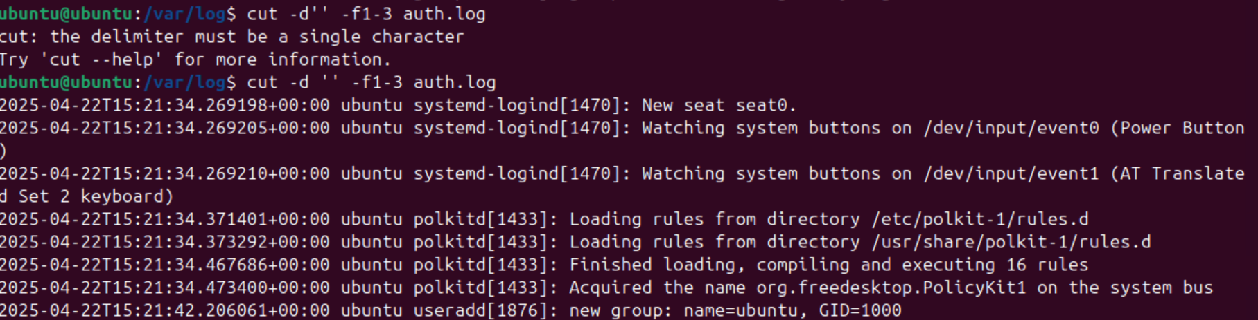
Here, error comes due to lack of space between d and ‘ ’
cut -d ‘ ’ -f1-3 log file command is used to get first 3 fields from that particular log file.
MYSQL

CREATE DATABASE

USE Database_name


CREATE TABLE:
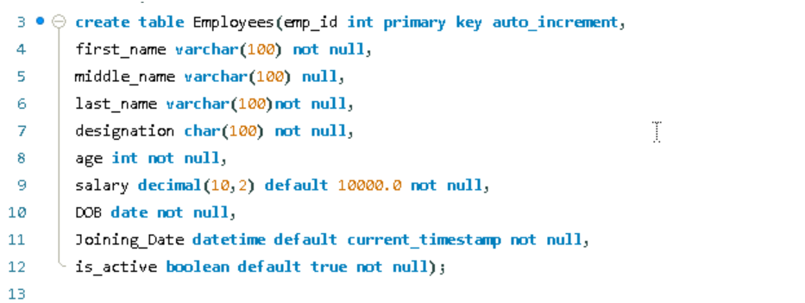

INSERT VALUES:

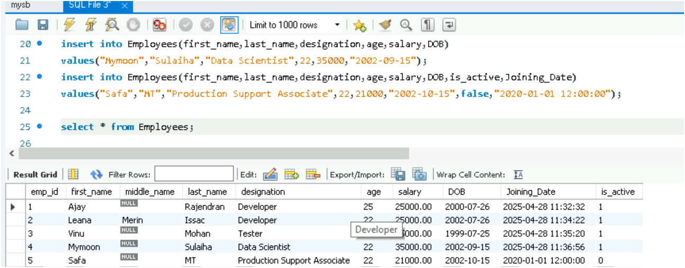

SELECT:
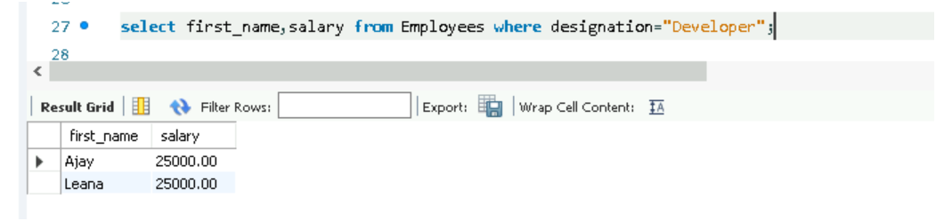

CONDITIONS

WHERE:
The WHERE clause in SQL is used to filter records that meet a certain condition.


AND:
Show records if all conditions are true.
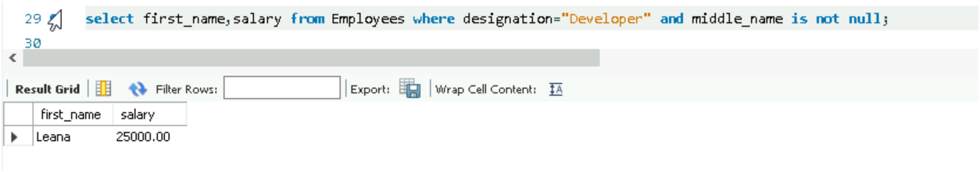

OR:
Show records if any one of the condition is true.
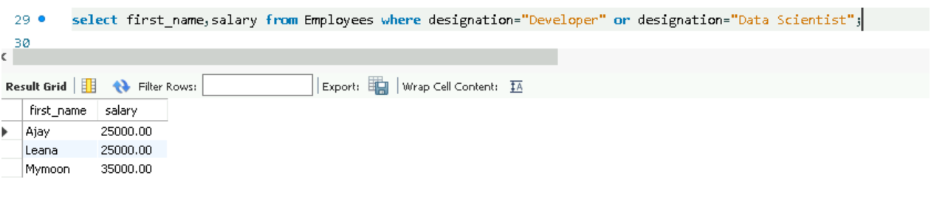

NOT:
Show records if conditions are not true.
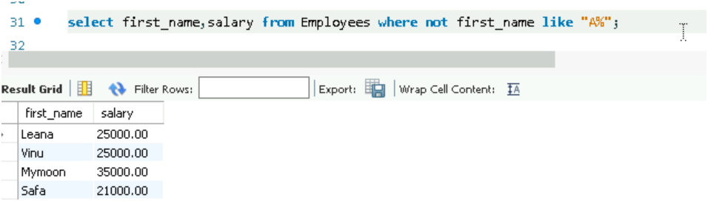

IS NULL:
It is used to filter the rows where specific column has null value.
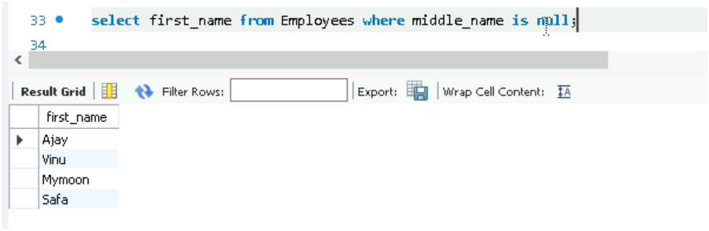

IS NOT NULL:
It is used to filter the rows where specific column has non null value.


AGGREGATE FUNCTIONS
MIN():
Returns smallest value of selected column.
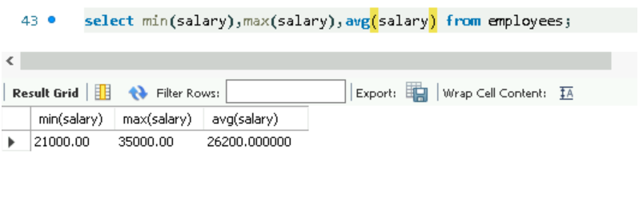
MAX()
Returns largest value of selected column.


COUNT()
To check the number of rows which satisfies a specific condition.
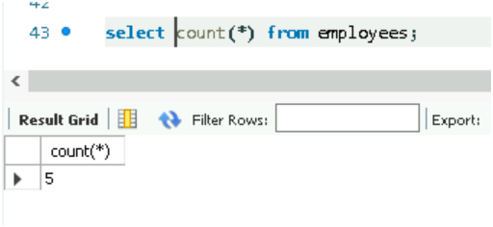
AVG()
To get average value of selected column .


SUM()
To get the sum of numeric column.
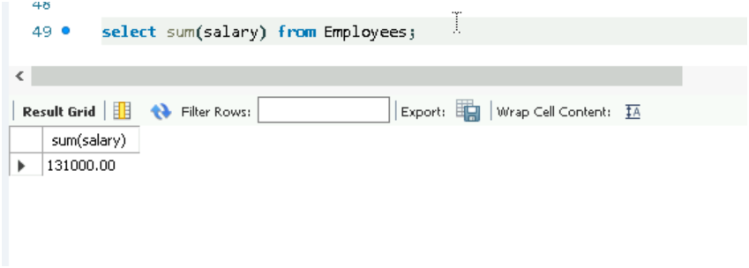

DISTINCT()
To retrieve the unique value from specified column in a table.
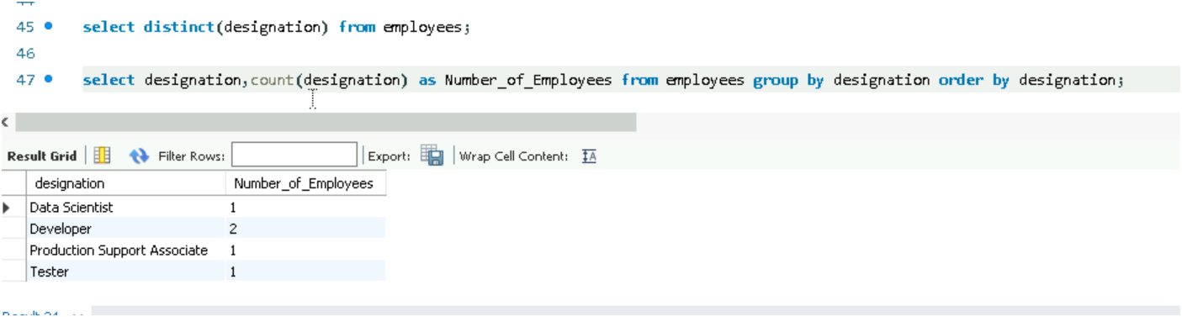
GROUP BY
Gather and organize your data into groups based on certain characteristics.

ORDER BY

UNION
Combine the result sets of 2 or more SELECT statements into single result set.
IN
Used to check if a specified value matches in your table.
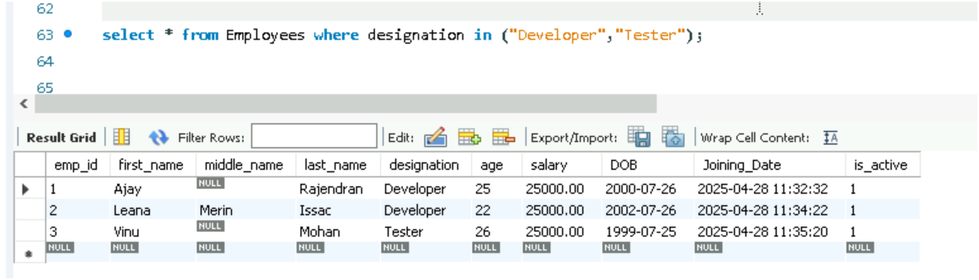
BETWEEN
Specify range of values in a table.
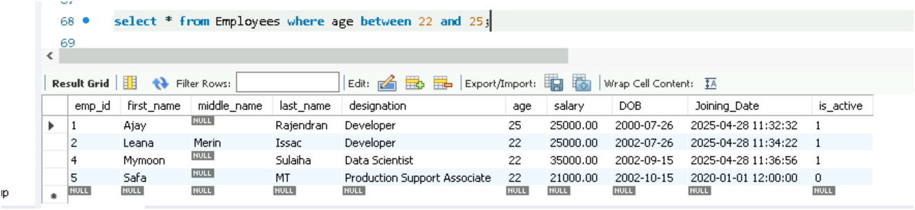
LIKE
Used to perform pattern matching within string values.
Wild cards
Special characters used in conjunction with LIKE to perform pattern matching with string values.
- % wild card
Used to match any sequence of characters in a string.
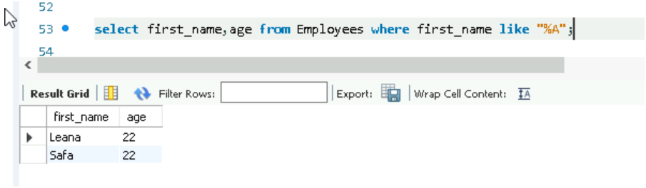

- _ wildcard
Used to match any single character in a string.
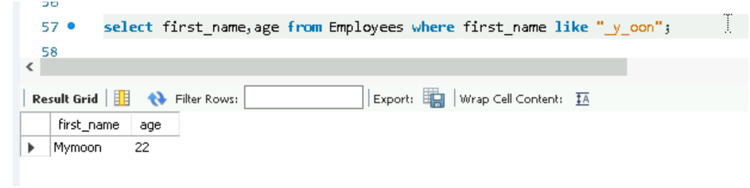

ALIAS
COLUMN ALIAS
Allows you to assign a temporary name to a column.
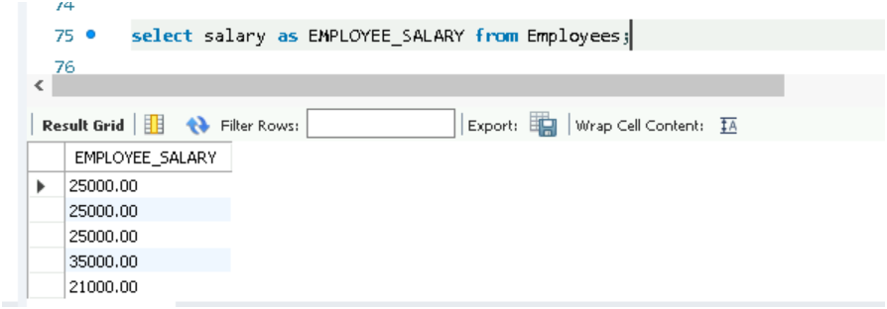
TABLE ALIAS
Allows you to assign temporary name to a table or subquery in SQL statement.
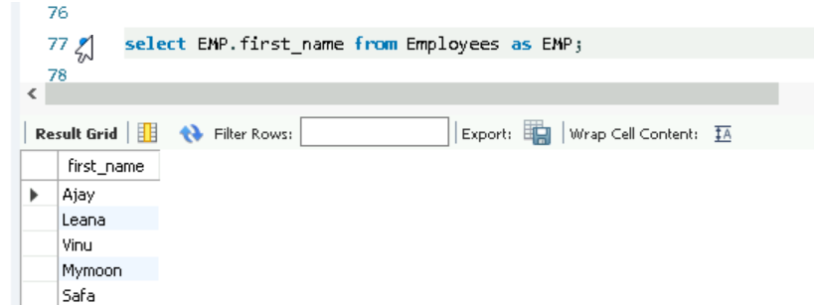
HAVING
Used to filter the results of a group by query based on aggregate functions.
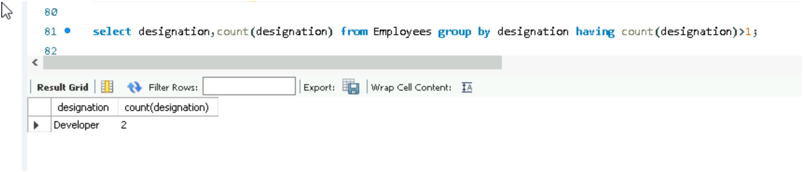
EXISTS
Used in conjunction with subquery to check if a certain condition holds true.
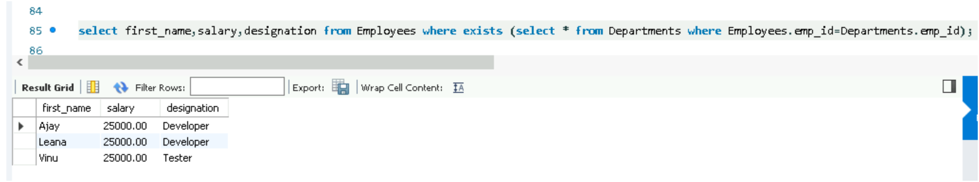
LIMIT
Used to restrict the number of rows returned by a query.
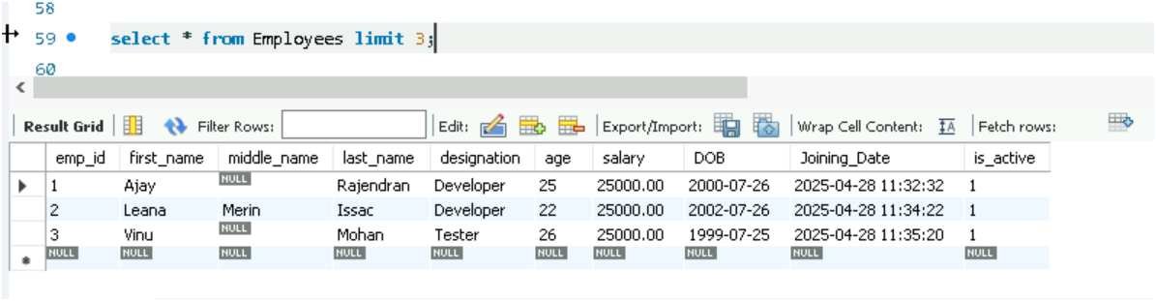
JOINS
INNER JOIN
To fetch matching records of both the tables.
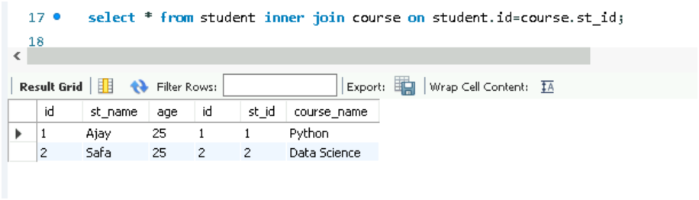

LEFT JOIN
To fetch all records from left table and matching records from right table.
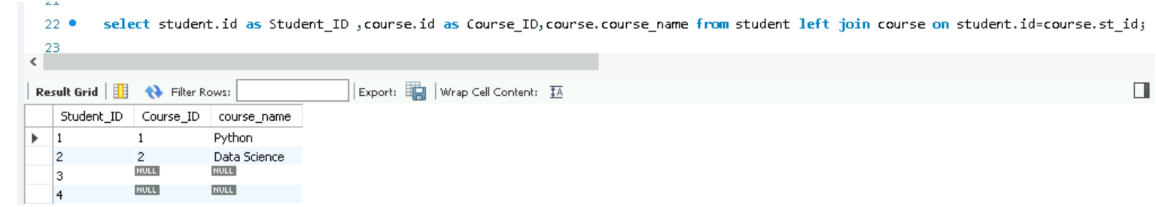
RIGHT JOIN
To fetch all records from right table and matching records from left table.
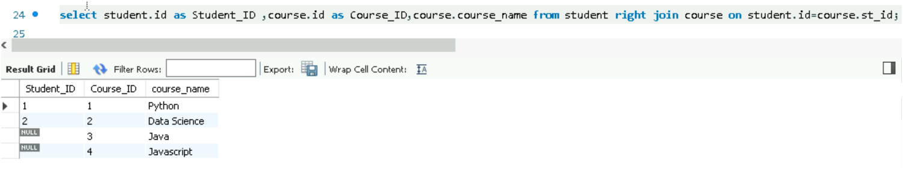
FULL JOIN
To fetch all records when there is a match in records.
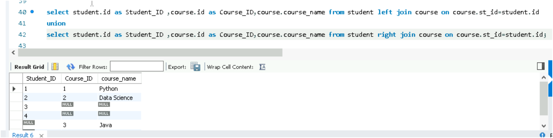

TROUBLE SHOOTING
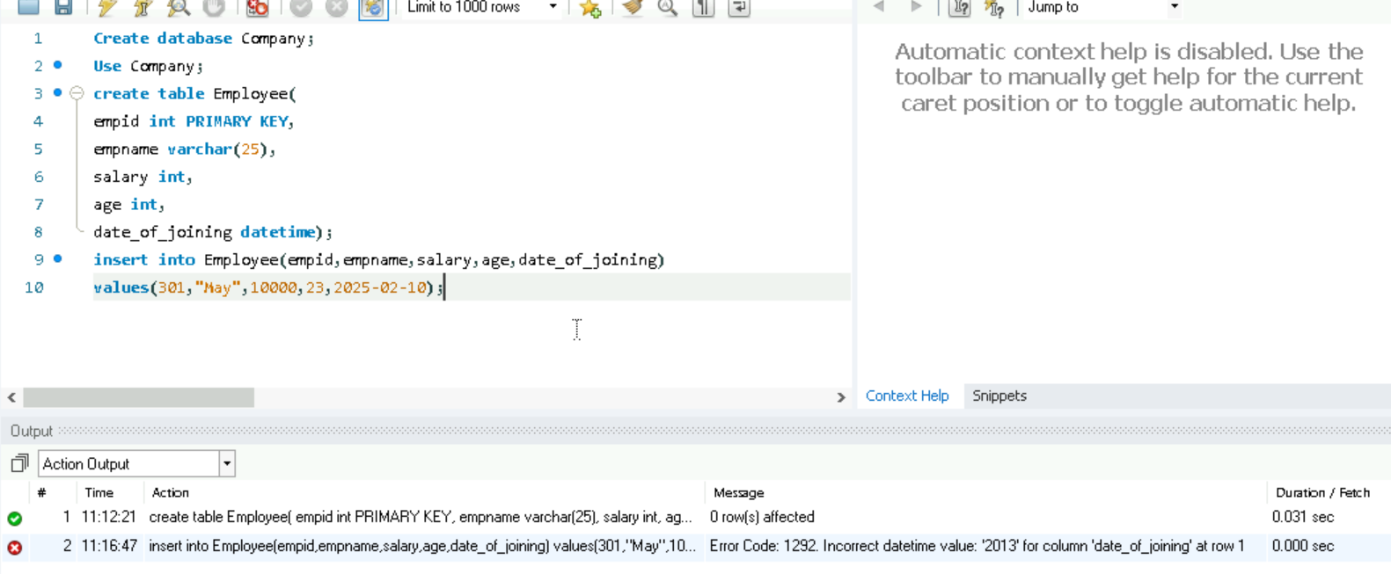
Here error comes when date is not given inside quotes, so we have to enclose date within quotes.
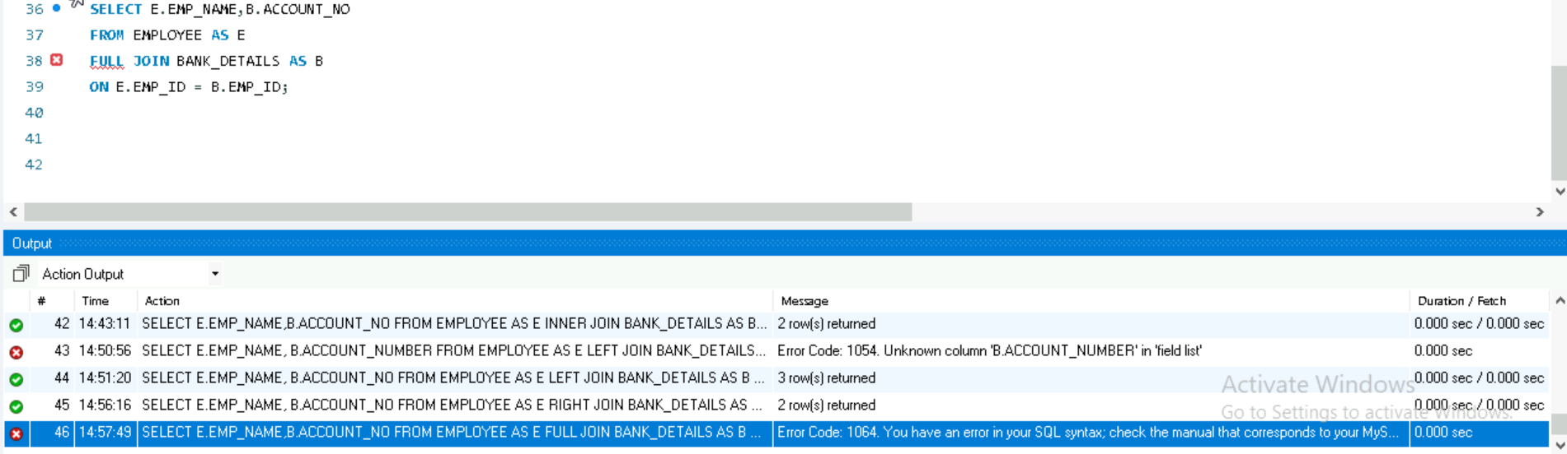
Here we got error in FULL JOIN as MySQL Workbench interpreter does not support FULL JOIN.

